**Project Design Phase**

**Solution Architecture**

|  |  |
| --- | --- |
| Date | 26 June 2025 |
| Team ID | LTVIP2025TMID34781 |
| Project Name | Smart Sorting |
| Maximum Marks | 4 Marks |

**Solution Architecture:**

**📤 Step 1 – Image Upload  
User uploads or captures image of produce via a web interface**

**🧹 Step 2 – Image Preprocessing  
Resizing, normalization, and noise removal are applied**

**🧠 Step 3 – Classification via Transfer Learning  
A CNN model (e.g., MobileNetV2) trained on fresh/rotten datasets classifies the input**

**📊 Step 4 – Result Output  
Displays prediction label (Fresh/Rotten) along with confidence score**

**📁 Step 5 – Export or Log Results  
Results can be saved or downloaded in CSV/PDF format**

**Example - Solution Architecture Diagram:**

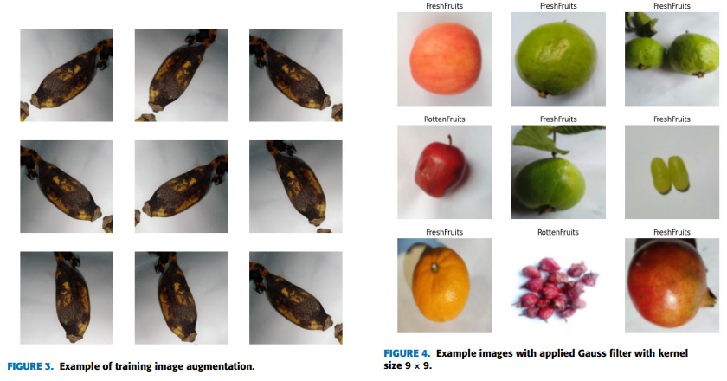

*Figure 1: Architecture and data flow of the voice patient diary sample application*

**Reference:** [**https://aws.amazon.com/blogs/industries/voice-applications-in-clinical-research-powered-by-ai-on-aws-part-1-architecture-and-design-considerations/**](https://aws.amazon.com/blogs/industries/voice-applications-in-clinical-research-powered-by-ai-on-aws-part-1-architecture-and-design-considerations/)